‘HopChik’  
Game Design Document

Dream Team

Olena Hrynkiw  
Pedro Loures

# Game Overview

## Game Concept

Play as Chit the Chicken as you spend days and nights braving the perilous forest searching for home - and more importantly, food.

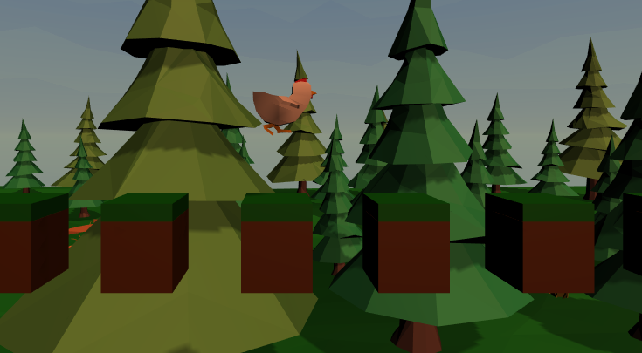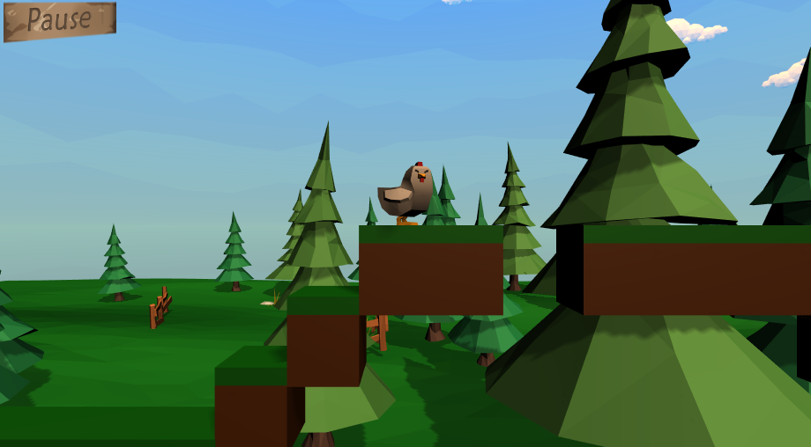

## 

## Genre

Side-scrolling mobile platformer built for Android users of all ages looking for a challenge.

## Game Flow Summary

As you make your way through various obstacles and past enemies, you will occasionally encounter glorious food. Reach it, and you’ll have a safe space to which you can revive if you get injured later (must watch an ad or purchase unlimited revives).

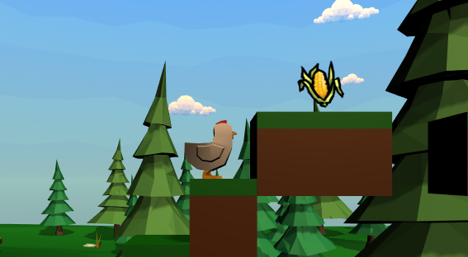

# Gameplay and Mechanics

## Objectives

The main objective is to complete the level! With all the enemies and obstacles in the way, this is a huge achievement. Reaching checkpoints is considered a sub-goal to this objective, though they do not persist between sessions.

## Game Rules

If you fall off an edge or hit an enemy, you will die and have to restart the level unless you watch an ad or purchase revives.

## Game Movement

Players move left by pressing the left half of their screen, and similarly for moving right. To jump, just swipe up anywhere on your screen. Directional jumps can be achieved by swiping up while already moving in that direction.

# Interface

## Visual System

*Main Menu & Sub Menus*

**Main Menu**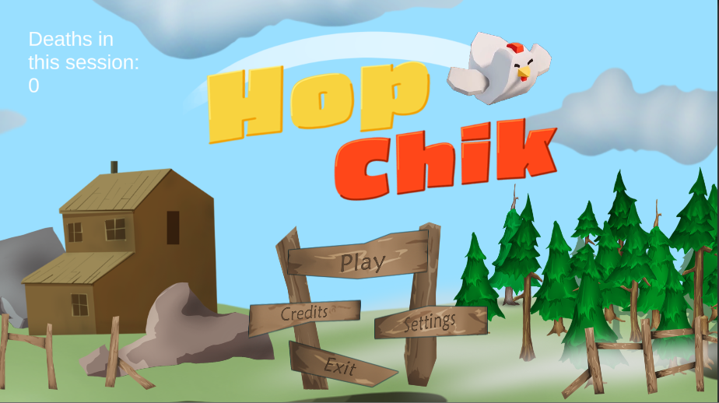

The main menu consists of 4 buttons(Play, Credits, Settings, and Exit) and a death counter. The death counter in the top-left of the screen will track deaths per session. Players can sart the game by tapping ‘Play’.

**Credits Menu**

The Credits button pulls up the related sub-menu which will show the tasks done by each group member.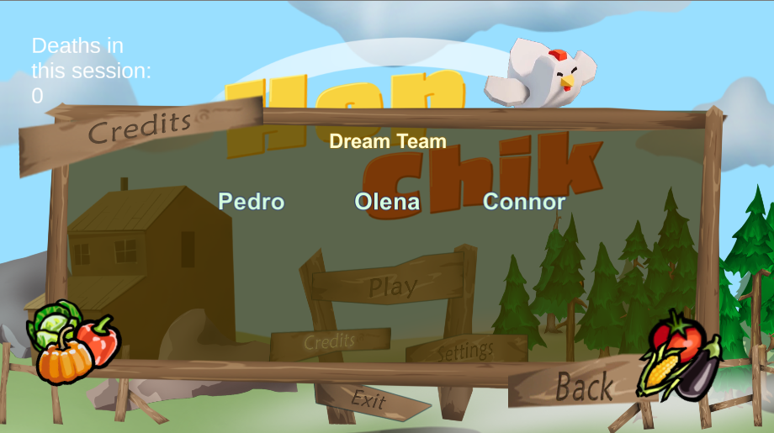

**Settings Menu**

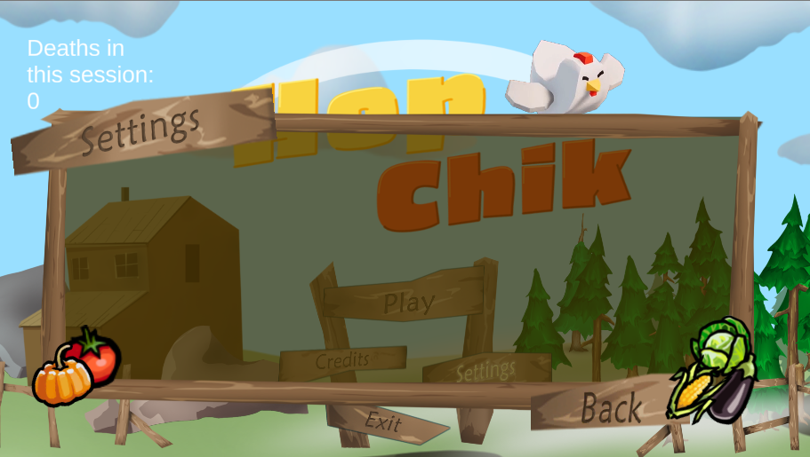

There is a panel for sound settings, which will allow players to adjust the volume of sound effects and music.

**Exit Confirmation Menu**

To exit the game, players can select the Exit button, and then hit ‘Yes’. If they choose to return to the game, they can just tap ‘No’. 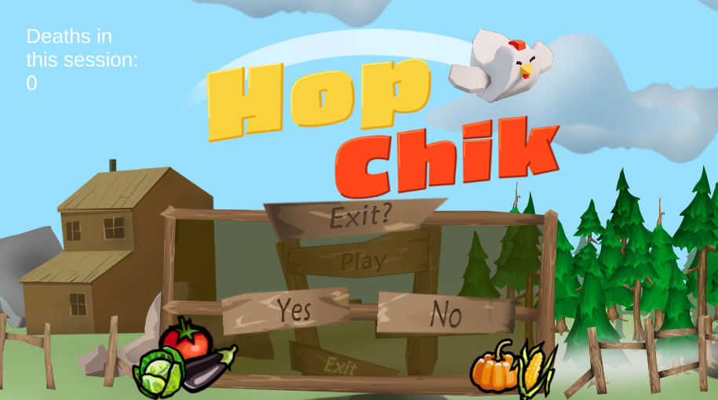

*In-Game UI*

**HUD**

There is no gameplay-related HUD, only a pause button.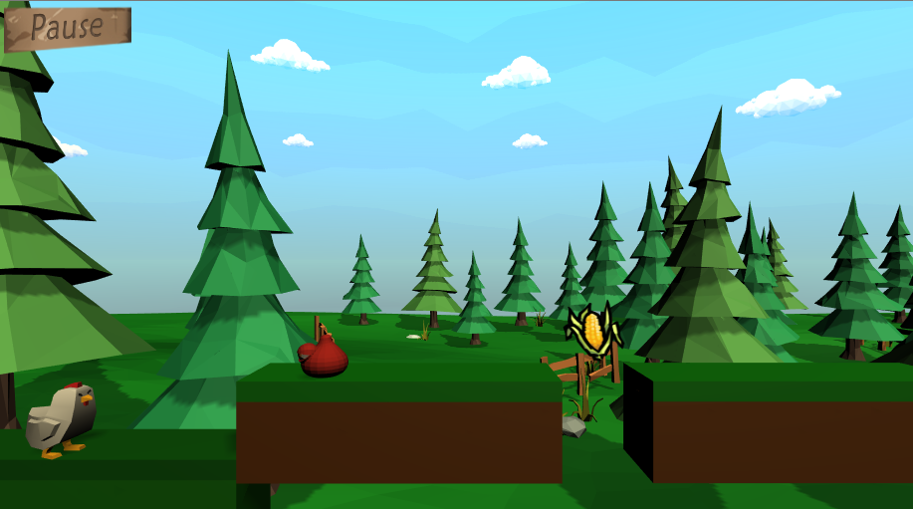

**Pause Menu**

Clicking the pause button will pause gameplay and open this menu, where players can adjust sound settings, exit to the main menu, or return to the game. Selecting the Exit to Main Menu button will pop up a confirmation panel similar to the one on the main menu.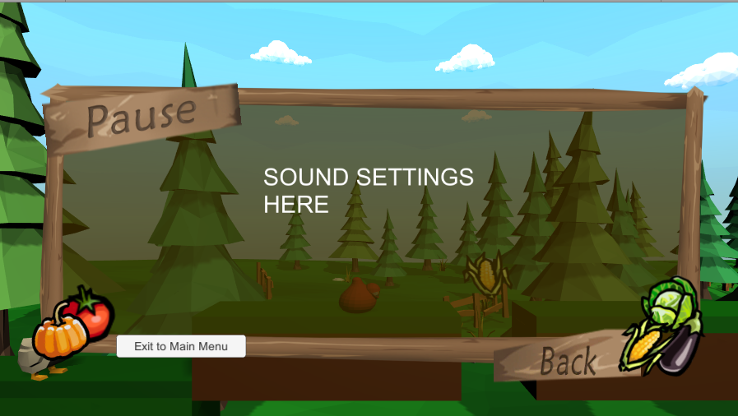

**Death Menu**

When players fall off an edge or get hit by an enemy, they will see this menu. Here, players can see their death count within this session and can tap the Retry button to restart the level. Similarly to the pause menu, the Exit button will pop up a confirmation panel and can take players back to the main menu.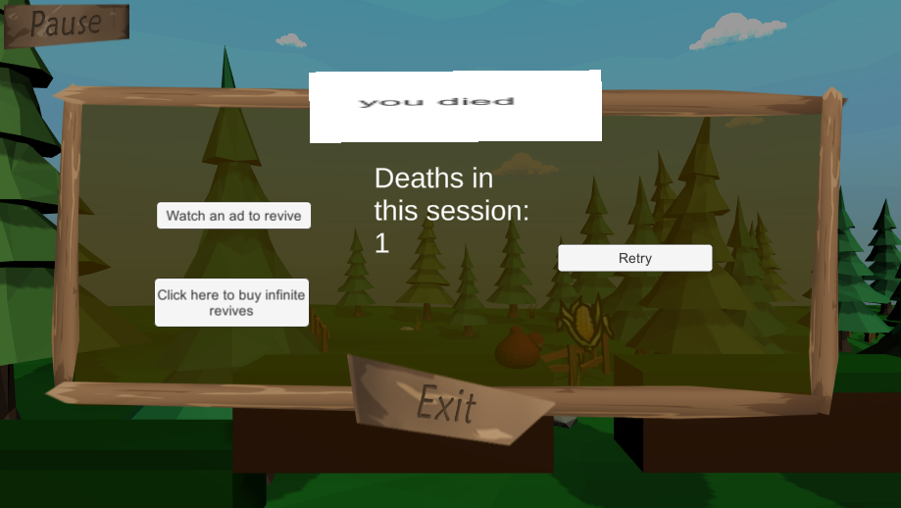

**Ad-Related Pop-ups**

If players don’t want to start from the beginning, they can watch an ad to revive the chicken at the location of the last checkpoint reached. These panels will pop up after the game tries to run an ad. Which panel shows depends on the result. If Players get an ad and complete it, they will get the top-left panel and will be revived at the last checkpoint they reached. If there are no ads available, they’ll get the top-right panel. If they skip the ad or exit early, they’ll get the bottom-left one. Finally, if the ad can’t run due to an error, the bottom-right panel will show. Each panel has a back button which will return players to the Death Menu, except the successful panel which will automatically revive the player.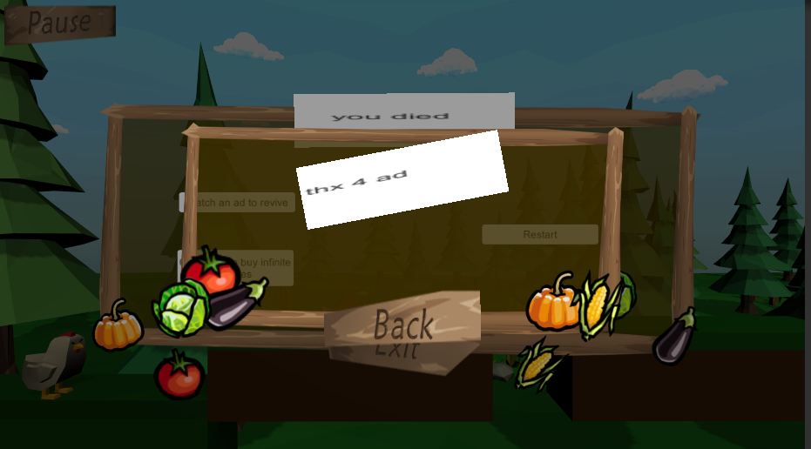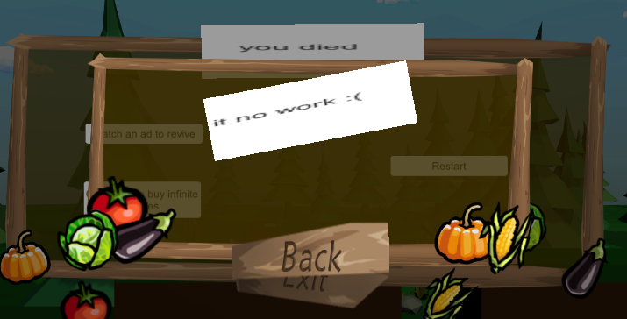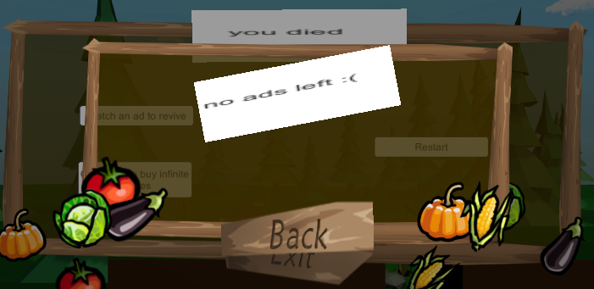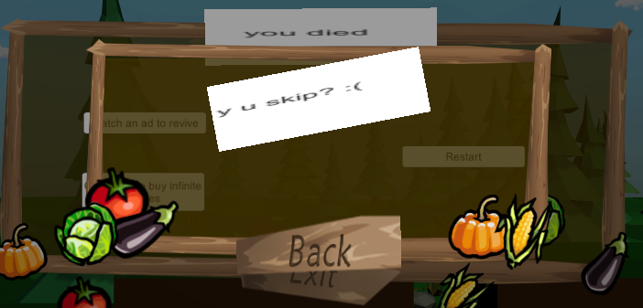

**IAP Confirmation & Related Pop-ups**

The IAP confirmation panel gives players the option to back out of subscribing for free revives by tapping ‘No’. If players tap ‘Yes’, they will be taken to their respective play store to complete the purchase.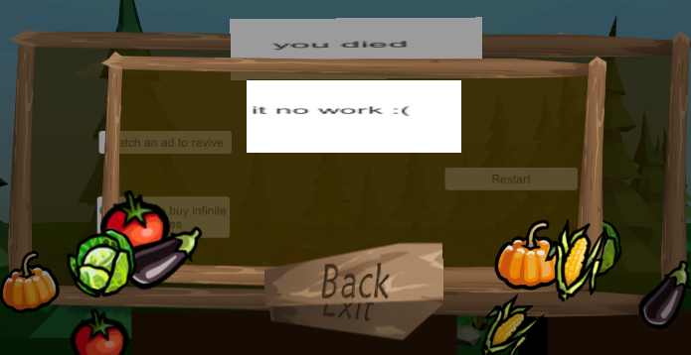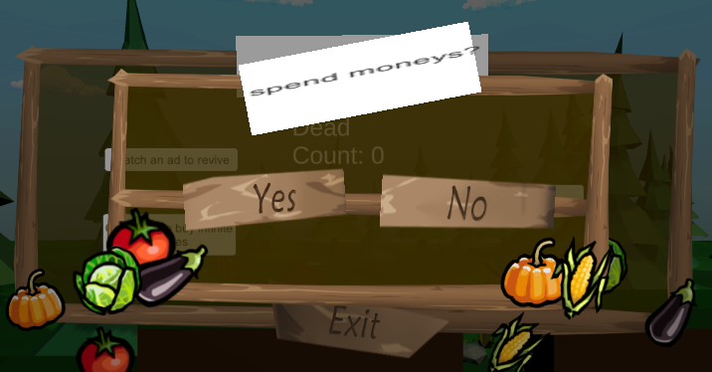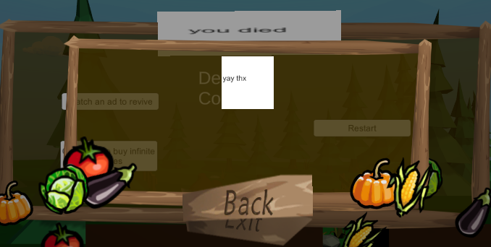

Two possible panels occur; if the transaction is successful, the confirmation panel on the left pops up; if unsuccessful, the error panel on the right pops up. Tapping ‘Back’ on the error panel will take players back to the regular Death Menu, while tapping it on the confirmation panel takes them to a modified Death Menu shown below.

After the purchase, the buttons to watch an ad and to purchase the free revive are replaced by a ‘Free revive!’ button. This lets players automatically revive at their last checkpoint.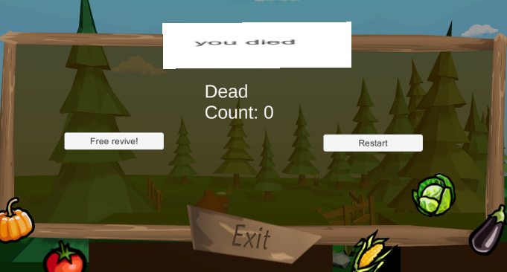

**Level Complete Menu**

Upon reaching the end of the level, players will see this menu. The final death count will be displayed in the middle, with the Exit to main menu button on the left, and the option to play again on the right. The Exit to main menu button will ask to confirm before returning players to the main menu; the play again button will reload the level for players to keep trying to master it.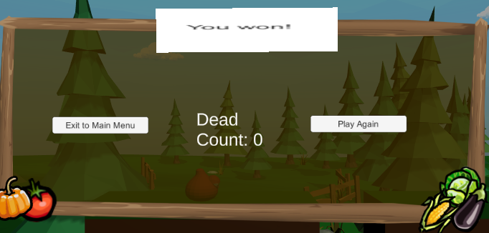

## Audio, Music, and SFX

There is preliminary music in the game for the menu and gameplay. There will be two background music tracks for gameplay, and some sound effects. In the future, the volume will be managed in the settings menus.